**Project Design Phase-II**

**Data Flow Diagram & User Stories**

|  |  |
| --- | --- |
| Date | 30 may 2025 |
| Team ID | LTVIP2025TMID42578 |
| Project Name | ResolveNow |
| Maximum Marks | 4 Marks |

**Data Flow Diagrams:**

A Data Flow Diagram (DFD) is a traditional visual representation of the information flows within a system. A neat and clear DFD can depict the right amount of the system requirement graphically. It shows how data enters and leaves the system, what changes the information, and where data is stored.

Example: DFD Level 0 (Industry Standard)

**Example:** [**(Simplified)**](https://developer.ibm.com/patterns/visualize-unstructured-text/)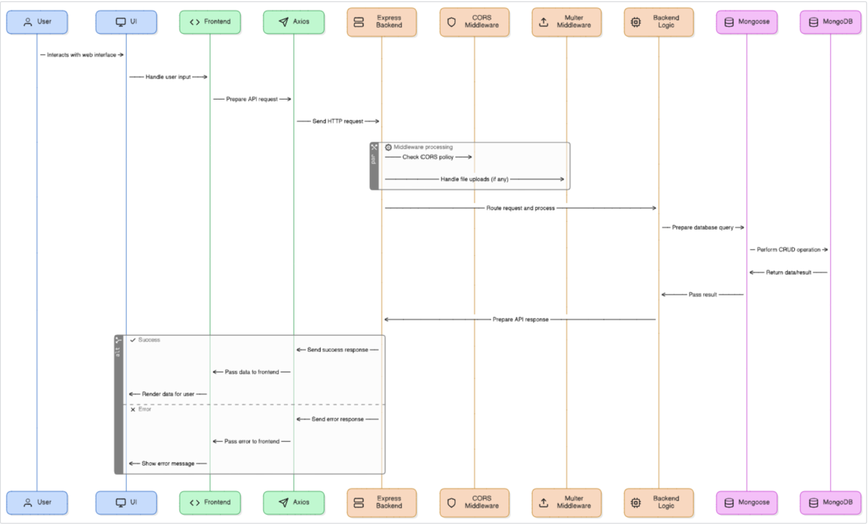

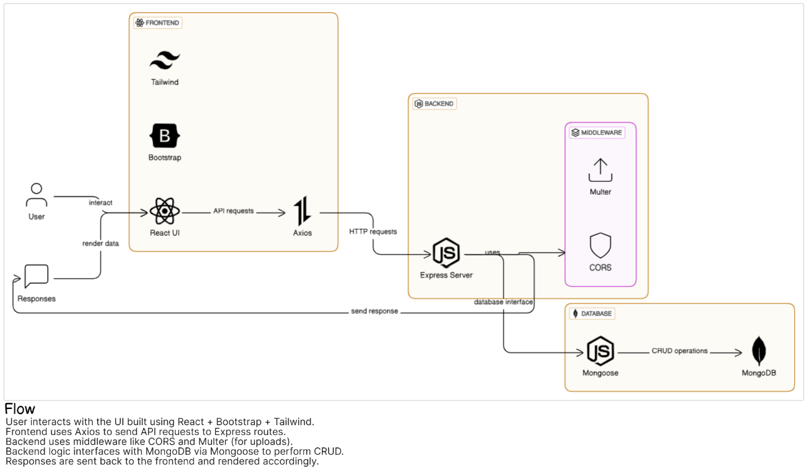

## 🔹 User Stories – ResolveNow

Use the below template to list all the user stories for the product.

| **User Type** | **Functional Requirement (Epic)** | **User Story Number** | **User Story / Task** | **Acceptance Criteria** | **Priority** | **Release** |
| --- | --- | --- | --- | --- | --- | --- |
| **User (Complainant)** | Registration | USN-1 | As a user, I can register using email and password. | I can log in and access the dashboard. | High | Sprint-1 |
|  | Email Confirmation | USN-2 | As a user, I receive a confirmation email after registration. | I can verify my account via email. | High | Sprint-1 |
|  | Social Registration | USN-3 | As a user, I can register via Google login. | I can register and log in using my Google account. | Medium | Sprint-2 |
|  | Login | USN-4 | As a user, I can log into the platform using email and password. | I can access my complaint dashboard. | High | Sprint-1 |
|  | Complaint Submission | USN-5 | As a user, I can submit complaints with category, description, and attachments. | Complaint is saved and auto-assigned. | High | Sprint-1 |
|  | View Complaint Status | USN-6 | As a user, I can view the real-time status of my complaints. | Complaint statuses update (e.g., Assigned, In Progress). | High | Sprint-1 |
|  | Chat with Agent | USN-7 | As a user, I can chat with the assigned agent in real-time. | Messages appear instantly in chat history. | High | Sprint-2 |

### 🔹 User Stories – Support Agent & Administrator

| **User Type** | **Functional Requirement (Epic)** | **User Story Number** | **User Story / Task** | **Acceptance Criteria** | **Priority** | **Release** |
| --- | --- | --- | --- | --- | --- | --- |
| **Support Agent** | Complaint Assignment | USN-8 | As an agent, I receive auto-assigned complaints based on skill. | I see complaints relevant to my role/skills. | High | Sprint-2 |
|  | Complaint Handling | USN-9 | As an agent, I can view complaint details and respond via chat. | I can mark complaint statuses and reply to users. | High | Sprint-2 |
|  | Workload Dashboard | USN-10 | As an agent, I can see my assigned complaints and status. | Only my complaints are visible on my dashboard. | Medium | Sprint-3 |
| **Administrator** | User Management | USN-11 | As an admin, I can add/remove users and set roles (User, Agent, Admin). | Roles reflect in dashboard access and permissions. | High | Sprint-3 |
|  | Manual Reassignment | USN-12 | As an admin, I can manually reassign complaints to agents. | Complaint updates reflect immediately on both dashboards. | Medium | Sprint-3 |
|  | Skill Configuration | USN-13 | As an admin, I can define skills and assign them to agents. | Agent skill list updates and affects routing. | Medium | Sprint-4 |
|  | Assignment Logs | USN-14 | As an admin, I can view logs of complaint assignment history. | I can audit who handled each complaint. | Low | Sprint-4 |
|  | Analytics Dashboard | USN-15 | As an admin, I can view metrics like resolution time and reassignment rates. | I see visual summaries in charts/tables. | Medium | Sprint-5 |